1．Put the following problems into standard form.
(a). Maximize 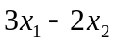
subject to
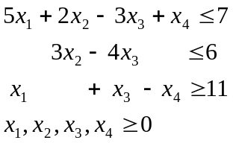
(b). Minimize 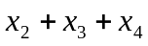
subject to
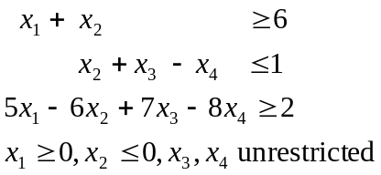
(c). Maximize 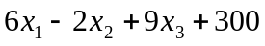
subject to
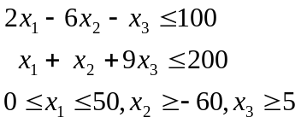

2. A system of equation is redundant if one of the equations in the system is a linear combination of the other equations. Show by using the pivot operation that the following system is redundant. Is this system equivalent to a system of equations in canonical form?
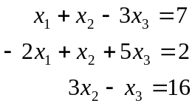

3. (a) Solve the following system of equations by finding an equivalent system in canonical form with basic variables  and 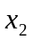.
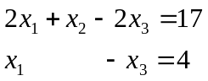
(b) Is this system equivalent to a system in canonical form with basic variables and ?
(c) Interpret these results geometrically.

4. For the linear programming problem of
Minimize 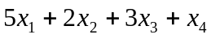
subject to
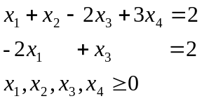
- Show geometrically that there can be only two basic feasible solutions to the problem.
- Compute these two basic feasible solutions.
- Show that the objective function is bounded below.
- Assume that the minimal value of the objective function is attained at a basic feasible solution, and determine this minimal value.

